INTRODUCTION
TO THE
INTERNET

Joyce Betz
Jackson District Library
244 W. Michigan Ave.
Jackson, Mi 49201
517-788-4099 ext 260
www.myjdl.com
November 2010

Introduce yourself to the class, Tell them a little bit about your experience
Have them introduce themselves Ask them what they want to learn from this class. If you have a board or easel available write them down.
(They will say things like everything. How to cut and paste how to type a résumé – Point out that you only have an hour and half, and they need to learn the basics first. Then tell them what your goals for the class are.
I usually ask them if this is what they were looking for, most of them will indicate it is then I say “Good I don’t have to go home.”
CLASS OBJECTIVES

By the end of the session participants will
- Use a Web browser
- Be introduced to and use a Tool Bar
- Be introduced and use a search engine
- Know how to set bookmarks or favorites
- Complete a search and find usable information.

What is the Internet

Show them this description, It is not necessary to read it, Tell them they can take it home and read it at their leisure.
In short, the Internet is a worldwide network of smaller networks. A network is basically a group of computers agreeing to talk to each other over some son of wire, electromagnetic wave, or fiber optic cable. Physically, computers in a network are connected together by cables that allow the computers to share information. Computers can communicate with each other if all speak the same language. Computers that are "on the Internet" all use the same protocols to send information back and forth. As long as a computer uses these protocols, it doesn't matter what type of hardware or software it uses. In addition, every computer that is attached to the Internet also has an address that helps other computers locate it.
The Internet is a worldwide network of computers, and the World Wide Web is the most popular way of using the Internet to organize and link information. The Web uses hypertext to link documents with a graphical "point-and-click" interface. Other ways of using the Internet include e-mail, file transfer protocol (FTP), Telnet, and Usenet.
The Internet began as a project of U.s. Department of Defense called ARPANET. The goal of this project was to design a nationwide computer network that could withstand major disasters. If one part of the network is destroyed, the other parts would be able to stay up due to the decentralized structure of the network. At the very beginning, there were four computers in the U.S. attached to the network; today, there are millions all over the world.
In the Internet's early days (the 1960s and 70s), only government, military, and educational institutions had computers connected to the Internet. The Internet was originally intended to be used for research and scholarly communications. But as it grew, the Internet began to be used for informal communication, entertainment, and eventually commercial purposes with the connection of businesses in the 1990s. Now requests for information, such as product availability or credit status, can be made and results returned in a few seconds, even though the message may have traveled thousands of miles over the Internet.
At the center of the Internet are the servers. Servers are computers that store lots of information for other computers to download and view. When you look at a Web page, you are a client and the computer you look at is the server, sending its Web page to you over a tangle of wires, routers, and switches.
Today's Internet is a web of connectivity including telephone service providers, regional Internet Service Providers (ISPs), local ISPs, and millions of end users who access the information or post sites on the Internet via an ISP. The telephone companies or other large providers sell connectivity
Copyright © 2000 Bill & Melinda Gates Foundation
What is the Internet? (Continued)

to Regional ISPs who lease part of their own connectivity to local ISPs or end users. The local ISPs then also sell pan of their connectivity to other end users. Needless (to say, this can lead to a lot of ISPs-by 1997 there were over 5,000 ISPs in the United States alone. And some of the large providers, like AOL and CompuServe, sell access directly (0 end users.
The Internet works smoothly because all the companies involved have agreed to exchange traffic (data) with one another. An end user (like a library in Alabama or a person with a home computer) is part of a local ISPs network, which is part of a regional ISPs network, which is part of an even larger U.S. network, which connects to a worldwide network and all these networks talking to each other over the globe are the Internet!

Copyright © 2000 Bill & Melinda Gates Foundation

Explain the following page- the different parts of the internet

IRC stands for Instant relay chat, Sometimes have chat rooms where you can talk to several people at once.
You “chat” text, with someone on the computer, Now days they use the phone,

USENET is like a bulletin board- a board for almost any subject. Kayaking, snowboarding, mountain climbing, Child care, education, quilting Etc. You post something, someone or many others answerit.

Email – Short for electronic mail. Send to people all over the world.

FTP, Gopher and Telnet are also parts of the internet,

The World Wide Web is just part of the internet, When most people talk about the internet what they are really talking about is the World Wide Web, That is what we will be talking about today.

The backbone of the Internet are the large communications companies.
From there you Have Internet Service Providers (ISP) you pay them a monthly fee, to use their equipment and expertise.
There are different types of connections.
- Dial –up through your phone line- cannot receive phone calls when using Internet. Least cost
- DSL (Direct Service Link) still through phone line, but can still use phone. Faster connection intermediate cost
- Cable like your cable TV, faster more expensive
- Satellite- like Satellite TV. Most expensive.

This illustrates how the World Wide Web is one of many Internet applications.

Usenet
Gopher
Other Applications
World Wide Web
FTP
Telnet
E-mail
Users

THE INTERNET
ISP (like
AOL, PSI,
Compuserve)
 |  | Network |  | Network
ISP (like |  | Network |  | Network
AOL, PSI,
Compuserve) |  | Backbone |  | Backbone
 |  | Service |  | Service
ISP (like |  | Service |  | Service
AOL, PSI, |  | (such as MCI, ATT, |  | (such as MCI, ATT,
Compuserve) |  | US West) |  | US West)
 |  | Network |  | Network
ISP (like |  | Network |  | Network
AOL, PSI,
Compuserve) |  | Backbone |  | Backbone
 |  | Service |  | Service
ISP (like |  | Service |  | Service
AOL, PSI, |  | (such as MCI, ATT, |  | (such as MCI, ATT,
Compuserve) |  | US West) |  | US West)
ISP (like
AOL, PSI,
Compuserve)
ISP (like
AOL, PSI,
Compuserve)
ISP (like
AOL, PSI,
Compuserve)
Users

IRC
Go over each item quickly,
Internet Glossary
Browser (short for web Browser) You may get questions about the difference in a web browser and a search engine.
A type of software program that allows users to find and connect to Web pages. Two of the most popular browsers are Netscape Navigator and Microsoft Internet Explorer. These allow the user to move back and forth between pages through links.

E-mail (short for Electronic Mail)
The transmission of messages electronically. E-mail can be limited to a single computer system or network, or can allow much broader connectivity. Most e-mail systems allow you to send the same message to one or many people.

FTP (File Transfer Protocol)
A standard protocol used to send files from one computer to another on the Internet.

Home Page
The opening page of either a personal, commercial, or institutional Web site.

Hot Links (or Links)
In hypertext systems, such as the World Wide Web, links allow you to move from one document page to another. When you click a link, you access another Web document.

Hypertext
A special type of database system in which objects (text, videos, audio, graphics) are linked to one another. In a hypertext, system movements by the user are not linear or predetermined. Rather movements between objects of various forms are chosen uniquely by the user. For example, while reading a document chronicling the Seattle Mariners 1997 season, a user can click the words Ken Griffey Jr. and retrieve a graph of Junior's batting statistics for the season. The user can then click the link Home Runs and see a video of Junior's famous swing.

HTML (Hypertext Markup Language) Show them HTML source for a webpage. So they can see how complicated it is.
The language used to create a Web document.

HTTP (Hypertext Transfer Protocol)
An agreed upon format (protocol) used on the World Wide Web to retrieve HTML documents. Also the first part of many URLs.
Copyright © 2000 Bill & Melinda Gates Foundation
Internet
A global "network of networks" connecting more than 1 million computers and supporting more than 58 million computer users worldwide. See the Handout: "What is the Internet?"

ISP (Internet Service Provider)
An ISP is a company or organization that provides Internet access to individuals and institutions, usually for a fee. The service provider gives you a software package, user name, password, and access phone number. With a modem, a user can log on, browse the World Wide Web, and communicate with others through Usenet and e-mail.

Modem (Acronym for Modulator-Demodulator)
A modem is a device attached to a computer or a program within the computer that allows the computer to transmit data over a phone line. Computer information is stored digitally while information transmitted over the phone line is sent in the form of analog waves. The modem converts from digital to analog when information is sent and from analog to digital when information is received.

Online Services
A business that provides its users with a wide variety of access to data transmitted over the phone lines. These service providers create an infrastructure with which a large number of users can communicate with one another via e-mail, chat groups, and access to the World Wide Web. Three of the largest online services are American Online, Compuserve, and Microsoft Network (MSN).

Search Engine You may get questions about the difference in a web browser and a search engine.
A tool to find documents on the Web. At great speeds, the search engine will search through millions of Web pages and select those with specific words and phrases as chosen by rhea user. Popular search engines include Aha Vista, Excite, InfoSeek, and Harbor.

URL (Universal Resource Locator)
A document address. For example: http://www.techresource.org. The URL tells the computer how and where to look for a document.

Copyright © 2000 Bill & Melinda Gates Foundation

Internet Glossary (continued)
Usenet
A worldwide bulletin board that can be accessed through the Internet or an online service.
The Usenet contains newsgroups that form to discuss every topic you can imagine and even
more than you've never thought of. It is accessed by millions of people each day around the world.

World Wide Web
A system of linked comparers that support specifically formatted documents that include links to other documents as well as graphics and audio and video clips. When linked to the World Wide Web you can jump from one document to another simply by clicking the hour links. The World Wide Web is the most popular part of the Internet as seen in billboards, commercials, bus advertisements, and even a banner at the Kingdome that begins with the letters "WWW."
~

Copyright © 2000 Bill & Melinda Gates Foundation

Ask participants what they think the best thing about the internet is, most of them will say information.

Tell them the best thing about the internet is that anybody can put anything on the internet. No one owns it. That is how all that information gets there.

Ask what is the worst thing about the internet- Many of them will say, pornography, some will say identity theft .

This is where , I talk about filters and pop up blockers and anti-virus software.
I have been using the Internet for over 15 years and I have accidently gotten to something disturbing about 3 times. Usually you have to be looking for it.

We need to be aware of and watch what our children are doing. http://www.youtube.com/watch?v=kxmG6VeNSuQ Howard Reingold, out of 1,000, 000 children on the internet 5 of them are molested by someone they met on the Internet. 50,000 are molested in their home, a neighbor or a family member, someone they know. Yes we should be concerned, Biography on WikiPedia http://en.wikipedia.org/wiki/Howard_Rheingold So yes we should be concerned about Childrens safety but we need to keep it in perspective.

The worst thing about the Internet is that anybody can put anything on the Internet and we need to know how to evaluate it.
Ask them what they did before the Internet if they heard about a product or political candidate). on the radio or TV.

Point out each tool and explain briefly what it does. If you hold your mouse over it for a second it will tell you.
The Tool Bar

Title Bar
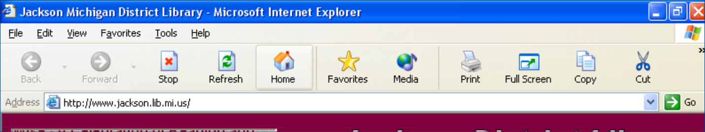
Tool Bar
Menu Bar
Address Bar

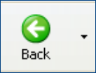
Click to move back to last view screen

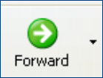
Imagine the pages you view as a continuum. If you backtracked to a previously viewed page the forward button will move you forward along the continuum.


Click the stop button to discontinue a search. Useful if the page seems to be taking too long to appear.

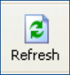
Click refresh when viewing pages that are updated frequently; stock quotes, traffic and weather reports, CNN.

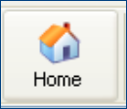
Click Home to go to the pre-selected Home page in this case the library’s home page.

The Address Bar

Address bar: The Website Address or URL is entered here.
- Erase the address that is currently showing by
  - clicking in the white space this will highlight the current entry, OR
  - use the backspace or delete keys to erase the current address,
Begin typing the new address,
- usually this starts with www, but you don’t need to type it .
- almost always uses all lower case letters
- no punctuation except, dots and slashes
Use the mouse to click the go button OR
Press the Enter key on the keyboard.

DOMAINS

Domain Name: A domain name is a company's unique identity on the worldwide
Internet.

Types of Domain

.edu an educational institution

.gov government

.org usually a non-profit organization

.com a business or company

.net an internet server

.mil Military

Domain types can help determine the validity of information. For Example: .com sites are commercial they are probably going to try to sell you something. The following guidelines were “borrowed from Foote Hospital. They refer to Medical sites but the points are still valid
Tips From The Foote Hospital
Health Education Resource Center:
Evaluating Information From The Internet

Check The Source Of Information. If the source of a health or medical Web site isn't readily obvious, proceed with caution. Good sites provide e.xtensive information about who's behind the content and what their mission is. Does the information come from a government agency, a hospital or university? If so, it is more likely to be legitimate.

Be Suspicious Of Any Site That Tries To Sell A Product. Be particularly cautious when a site promotes specific products or uses testimonials as evidence. Be suspicious of sites that dismiss mainstream science, contain statements that attack well-established medical policy, or offer a diagnosis.

The Site Should Give Varied Opinions. A good site will give different options and will be a link to other related Internet sites. Be wary of sites that only -promote one course of treatment.

Information Should Be Current. If a site hasn't been updated in several months, the information may no longer be accurate. A quality site updates at least monthly. An indication of stale content is error messages stating that the links followed are outdated.

There Should Be A Way To Contact The Site's Content Provider. The site should provide an e-mail address to give feedback or request more information. At the very least, an address and phone number should be listed. .
The Information Should Be Easy To Understand. The language from a Web site should not be filled with medical terminology or written in a manner that leaves the reader confused.

The Site Should Be Easy To Navigate. The features of the Web page should be logically organized and well defined. The most useful sites are those that are simple and rich in content, going so far as to offer a text-only version for nongraphic browsers.

- Any information found on the Internet should not be a substitute for a medical professional. Take the information back to your doctor to discuss your medical history and treatment options

Foote Hospital
Health Education Resource Center
787-0319
Tell students, If you know the web address you Simply type the address in the address bar.

Start by going to a few sites of interest.
I use mackinacbridge.org. look at the various views of the bridge and note the weather and road condition advisory,.

I have used HGTV.com when they have the dream house so they can see how to link to various rooms and views.

Use whatever sites you find fun or informative.

The idea is to give them a few sites to type into the address bar and see what kinds of sites are there.
Point out that if you know the name of a company you can probably figure out the web address.
For example Kelloggs.com , or pepsi.com or cocacola.com.

Remind the students that there are NO spaces in Web Address.

“If you don’t know the web address, you can use a search engine”

Using Search Engines (Tools to find documents on the Web, see glossary)

http://www.ask.com
http://excite.com
http://infoseek.go.com
http://www.looksmart.com
http://www.lycos.com
http://www.teoma.com/
http://www.37.com/
http://www.dogpile.com/
http://www.altavista.com/
http://www.google.com

We are going to use Google today. We may try some of the others later.
Type google.com in the address bar.

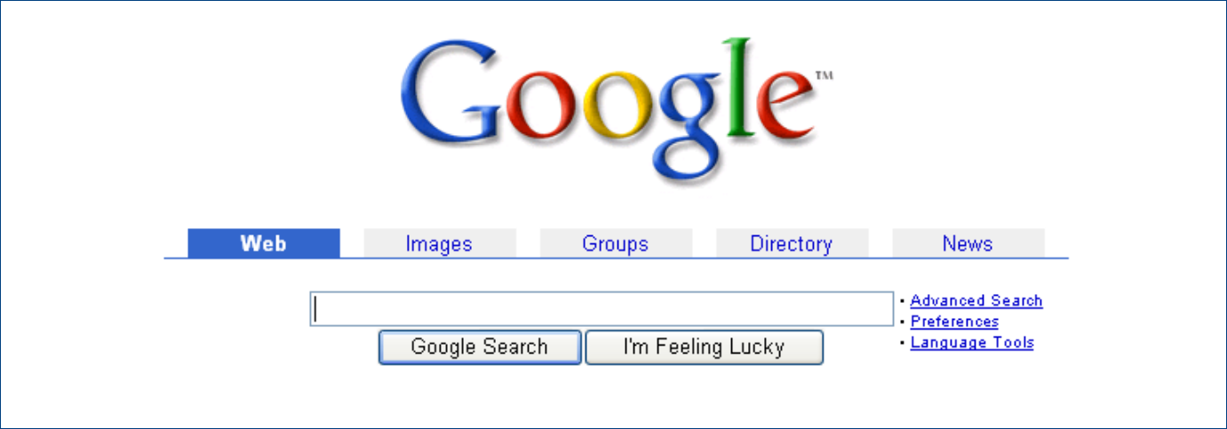
Search box

Type the subject or phrase you want to search in the search box.

Use real words, and spaces.
- Example: border collie, not bordercollie.
Spelling must be correct:
- you will not find what you are looking for if you type berder collie

Point out that the listings tell something about the site, they should be able to tell if it is likely to give them the information they need or want.
As an example I use (we had a huge bunch of gourds in our garden one year and decided to decorate the. So we dried them. Did you know gourds got fuzz mold on them when they dried? I had no idea how to clean them so I went to the Internet.

I typed Gourds – one of the things I came up with was a band call the gourds. And a lot of other information.

Point out how Google shows how many websites it found.

You may or may not find what you are looking for.

Go back to Google. Enter cleaning gourds. Point out how the sites found are better for what you are looking for.

Try a few other searches. – ask the class what they want to search for or come up with something of your own.

Point out that you can do a broad search or a more specific. If one doesn’t work try the other.

I sometimes have them search for their names- first and last. Some people who think they have a common name are amazed that there is nothing listed others are amazed at how many there are and even find a relative.

Show them how to limit the search by using quotation makes (it searches for that particular phrase. (John smith will look for anything with john or smith or smith john, quotations marks will look only for john smith.

.

Show them how to set a bookmark or a favorite, following the steps below point out that the directions a re in the hand out and they can follow them when they get home.

Set the bookmark – go to the home page,, go to bookmarks and click on the one they just set.
How to set Favorites

Favorites or bookmarks- help you mark a web page you would like to return to without having to remember the long or complicated web address.

When you have found web site you like.
Click the Favorites Menu in the Menu bar

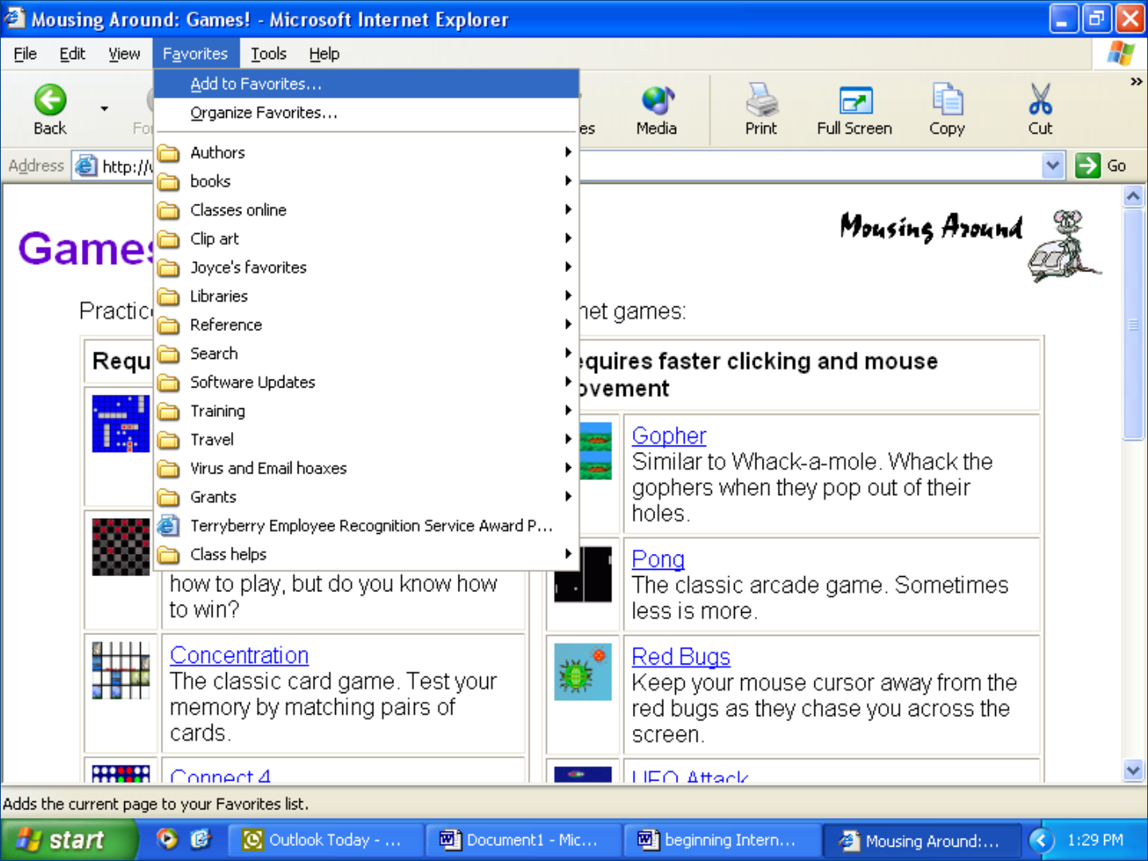
Then click
Add to Favorites

This Add Favorite Box will appear. Click OK

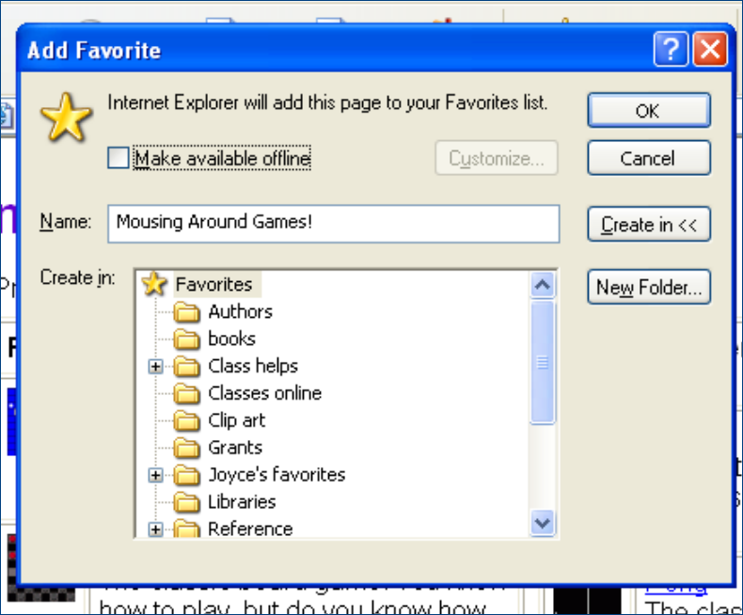

The title of the web page will then appear at the bottom of the Favorites menu. You can return to the web page any time you are online, by click on the title.

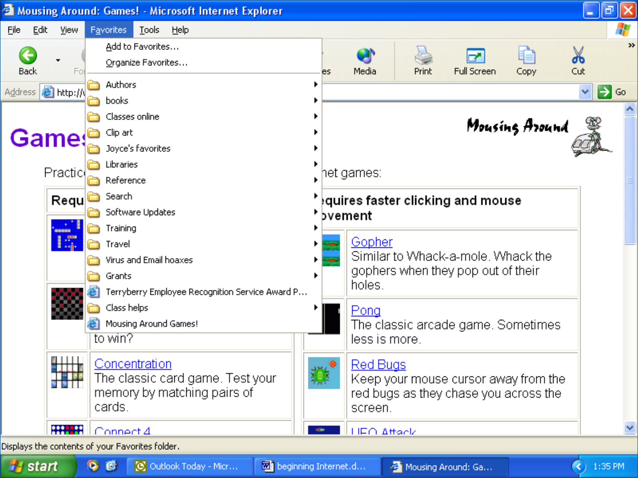

Give the sometime to practice. Walk around the room in case someone needs help.
Some of them may want to look for travel reservations. I usually point out that that would be covered in a different class. Some are looking for people and get to sites that want to charge them for information.

I have had people ask how all of this information gets on the Internet. Is it just floating around out there, where it is.

Others are amazed that they cannot find what they are looking for, like that long lost cousin

The sites on the next page may be something they would like to try.

The Michigan Electronic Library
http://mel.org

Yahoo
http://www.yahoo.com

The Internet Public Library
http://www.ipl.org

Yahoo Finance
http://quote.yahoo.com

Encyclopedia Britannica
http://britannica.com

Travel
Travelocity
www.travelocity.com/
Orbitz
http://www.orbitz.com/
Mapsonus
http://mapsonus.com/
MapQuest
http://www.mapquest.com/

The Internet Movie Database
http://imdb.com

CNN Interactive
http://www.cnn.com

Information Please
http://www.infoplease.com

The Switchboard
http://www.switchboard.com

Web museum
http://sunsite.unc.edu/louvre
http://www.ibiblio.org/louvre/

The Weather Channel
http://www.weather.com

Job Search and Employment
http://www.michworks.org/mtb/user/MTB_EMPL.EntryMainPage

Amazon.com
http://www.amazon.com

Michigan Government
http://michigan.gov/

Classmates.com
http://www.classmates.com/profile/home.html:

E-Bay
http://www.ebay.com/

Patron Workshop Evaluation Form

Workshop Title |  |  | Date

Held at |  |  | Instructor

Please rate each question below by circling the desired response- 1 being the least favorable and 5 being the most favorable.

1. | The material was presented clearly and understandably. 1 2 3 4 5

2. | The objectives of the workshop were clearly stated. 1 2 3 4 5

3. | The workshop met the stated objectives. 1 2 3 4 5

4. | The handouts were helpful and informative. 1 2 3 4 5

5. | How did you learn about this program?
 |  | Newspaper |  | Flyer |  | Radio |  | TV |  | Friend |  | Other

If other, please explain

Which branch(es) do you normally use

Comments or suggestions:

Would you like more information about this and other library programs? Please give us your name, address, phone number, and e-mail address.

